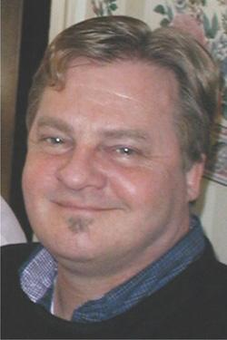
PAUL BERG SCHOLARSHIP APPLICATION FOR
Alliance for Community Media National Conference
August 18-20, 2016 – Boston, Massachusetts
This scholarship is named in memory of Paul Berg, former Executive Director of NewTV in Newton, MA. A graduate of Emerson College, Paul was extremely good-natured, intelligent, thoughtful, and fair, creating a collaborative atmosphere for his staff to share their ideas to improve NewTV. Paul generously shared his expertise with other stations, cities and towns. He received the Chuck Sherwood Leadership Award in 2005 from the ACM-Northeast Region. Paul passed away in February 2015.
Name:

Address:

Home Phone: Work Phone:

Fax: E-Mail:

Media Facility Affiliation:

Please select below:
Are you a member of the ACM? No YES: Individual Organizational

Are you a staff member of an access center? YES NO

IF YES: Annual Budget Number of FT Staff or Equivalent

IF NO: I am a Board Member Producer Other

Describe your involvement with your PEG station:

How long have you been involved in PEG Access and what do you get out of your involvement?

What do you believe are the biggest challenges facing your community’s PEG access?

How will attending an ACM National Conference help you with your future plans in PEG access?

Have you ever participated in any of the following Alliance for Community Media or your state chapter’s activities?
Hometown/Regional Awards Attend Workshop Legislative Visits

Phone/Email Campaign Other:

Have you received an ACM Grassroots scholarship before? YES NO

If YES, which conference did you attend?

Please FAX this application to: Karen Hayden, MCTV 978-689-0517
Or email to: methuentv@comcast.net
By 5:00 pm Wednesday, June 1, 2016

Scholarship includes full conference registration, up to two nights at the conference hotel, and money towards transportation. This scholarship is a partial reimbursement and receipts must be provided in order to receive the funds . If necessary, ACM-NE will front most conference and travel costs so that all can apply. Other expenses would be the responsibility of the recipient. The maximum value of the scholarship would be $1,000.

Winner(s) must write an article of at least 500 words about their experiences at the conference, be photographed and volunteer to be recorded for an ACM-NE promotional video.

